**Formatting From Aerospace Interview –**

*Who, where, and when you met your mentor –*

Portions Of “What He Does/Has Done” That Could Fit Here In “Who” –

* Masters program, Delphi internship (maybe during PhD?), PhD program, Bell Can, GE (the main company), then GE Aerospace –
  + He did most of his stuff when he was getting his Masters, working on hypersonic plasmas at Wright Patterson, and then for his PhD he worked on CFD code that the air force uses
    - His plasma stuff was more of testing, like they had a hypersonic tunnel and then they were trying to make a model off of the data they got
    - Computational Fluid Dynamics – CFD, Navier-Stokes Equations, running them in 2-D or 3-D simulations
  + Delphi –
    - He did have some experience working for an offshoot of Delphi, looking at different forms of door motors – just setting up some of the testing rigs and then collecting some of the data from it
  + GE (General) –
    - First 8-9 years was more commercial with the heat transfer thermal flow, now it is the fuel systems controls on the military side instead
      * Heat transfer was more of building models – flow models, 3-D heat transfer models (initially), there were a good amount of presentations , there’s also a lot more paperwork
  + GE Aerospace –
    - Fuel systems controls deals with the pumps, dealing with the flow control (where it is going in different directions), dealing with actuators that use fuel to move something
    - Mechanical systems deals with a lot of robotics stuff, he deals more with the individual actuators (they deal with everything else)
      * Basically told that he needs enough force/pressure to deal with something, he is essentially the muscle behind everything
      * You’ll find that there are lot of people that have a lot of fields, but for him he’s got more of a single focus
    - Fuel system controls, work on the system level, you’re coming up for individual requirements for an individual component
      * Doesn’t do it on a design level, but you tell suppliers the components, makes sure that they meet those requirements (a lot of paperwork to make sure they meet those requirements)
        + Checking some of the work, quick hand calculations, just trying to guage if the numbers make sense generally
        + Paperwork meaning laying out all the requirements on a pdf, you need to make a design best practices document, make sure that people are meeting all the requirements in the documents
        + Trying to link everyuthing together to meet the requirements

*What did you learn from the interaction? Especially, anything surprising? –*

Software & Programming Skills –

* Things I knew about –
  + Programming –
    - Fortran
    - C++
    - Python
  + Software - Navier-Stokes Equations
* Things I did not know about –
  + Python is used commonly because of how easy it is to learn and due to the massive amounts of modules/native capabilities it has, additionally Python is the big one to know going into the industry
    - Python isn’t the fastest, but it’s fairly easy to use and it’s got a lot of functions and models built into it (like statistics, predefined functions for manipulating databases)
      * You can take a lot of data and consume it
  + Specific name/what it is – CFD (computational fluid dynamics)
  + Unigraphics (now called NX) – A CAD modeling program that has more facets of 3-D design that just pure CAD modeling
    - UG has CAD bottling in there, but it has a lot of other things that it links on there when dealing with a product, and it covers more of the facets of 3-D design than just the CAD modeling
      * Facets as in cost, how things assemble together with different components, how things in manufacturing work, he doesn’t really work with that sdort of stuff but it’s essentially those sorts of things
  + Flow Network Modeling – Mathematical representations of flow using nodes and directed edges; this is a separate concept than linear programs.
    - Another on is probably also (geared towards his field) is flow network modeling – it’s basically a system of where the flow has to go through, up and down flow pressures and understanding what the pressure or flow changes (depending on your initial conditions) are – initial conditions are described as boundary conditions
  + FEA (Finite Element Analysis) – I feel like I’ve heard this somewhere, but I’m not sure
  + What boundary conditions are actually for (versus initial conditions) – They help to define how fluid coming from the boundaries behaves (or in a real-life test, how a fluid will behave entering the area we are focusing on)
    - In a model there are edges, and at the edges there are boundary conditions
      * It’s where the simulated fluid is coming from, so it’s how the fluid is acting going into the area we care about
    - Initial conditions are more for time-based stuff

Engineering Skills –

* General –
  + Learning the drawings, learning the stackups, learning the terminology is also another thing that would be good to know
    - Aerospace what you’re dealing with a lot of other parts work and fit together, so you need to understand on how parts will fit together and how the tolerances will work just based off of the drawings
    - Interpreting drawings wasn’t something that he was really directly taught, but it is a good skill to have
      * It was more on the fly
  + Some of the more basic mechanical design, getting the fundamentals of stress and basic mechanical calculations are useful
  + Another skill that is good to develop is to lok at a design problem and then break it down to a quick clacuation for an estimate so that it makes sense
    - These are the most important types of physics that we need to look at, here’s a simplified model, then get into a more complicated model
    - FBD are pretty important, making something a lot simpler
    - The large complex model is good, but you need to have checks to make sure that things are making sense (either on the whole thing or smaller parts of it)
      * The large models, it’s easy to put in some information wrong and then the results will diverge, so it’s important for things to make sense

Extra Courses To Take –

* Taking some material classes is probably a good idea, understanding the new materials is a valuable thing to understand
* Aerospace engineering, getting something on gas turbines would probably be a good idea, understanding the pressures, temperatures, etc. of it would be a good idea
* Additionally, the course that went over the basic design process and understand the process of designing an engineering product (understanding the different tools that you can use going through the design process – not software but just general processes that are used in the design)

Confidential Work –

* (Generally) How It Works –
  + There’s certain parts that are classified, you have to get security clearance, you need to report certain things in (like leaving the country), certain financial situations you’re in, regular drug tests also, the major pain in the butt part is dealing with being in a classified room (what information can pass in and out)
    - Plus if you’re working on classified stuff make sure you’re prepared to be in a closed-off room that you can’t see out of and you can’t bring certain electronics in either
    - Be careful and keep track of which information that is classified or not, and what you can and cannot talk about
    - Vacations, have to notify someone within a certain timespan and then a short interview after you come back
    - For some projects, some of it is classified but some is not, so you can take some of it home (and as long as you remember certain things you can adapt the classified to be ok enough to go home with, at least with the stuff he’s worked on, where he doesn’t need to be in the classified area all the time)
* Safety Worries/Social Engineering –
  + Safety isn’t much of a concern for him, but more of a concern is people trying to steal information from you through social networking/engineering
    - Paying attention to people asking questions you don’t know and if they’re asking something that doesn’t feel right, people trying to get you to give up information that you don’t want to and shouldn’t
    - Common examples of social engineering is through email or social media
    - There are probably more layers of protection on information getting out, potential red flags are being paid attention to more

Industry Stuff –

* GE Aerospace –
  + Out of college he got a job at Bell Can? A lot of CFD work there, then work there doing CFD modeling for elite fuel nozzle with GE. After two years he was told there was a position open at GE Aviation and that’s how he works for them now
    - It’s typical for them to make a position for people of the different departments (like general GE to GE Aviation)
* Academia –
  + He did most of his stuff when he was getting his Masters, working on hypersonic plasmas at Wright Patterson, and then for his PhD he worked on CFD code that the air force uses
    - His plasma stuff was more of testing, like they had a hypersonic tunnel and then they were trying to make a model off of the data they got

Financial Stuff –

* Benefits –
  + For 401k there will be a 5% match to whatever you pay there, there are bonuses of 10-15% of his salary, then the insurance costs are probably better insurance but now the people at GE Aviation have to pay for it (they got it for free in the past), but it’s cheaper (but has been creeping up for the past few years) – it is still better when compared to other fields (assumedly non-STEM)
* Salary –
  + Salary Progression –
    - Going into the workforce, it was a big jump from BellCan to GE, then 3-5% per year then two big steps when changing jobs, then last year there were salary adjustments based off of the workforce since a lot of new engineers were making more than the older workers, and his adjustment was more than he expected
      * The first big step was three years in and the second was 7-8 years in, he can’t really remember how much but it was bigger (ballparking) by 10% or something, he can’t remember specifically
  + Times of Financial Worry –
    - In terms of times when financial things were tighter, near the beginning when his wife was networking (when there weren’t two incomes) it was kind of a worry but now that there are two incomes there is not much of an issue.
      * You get used to having a certain amount of money to work with, you can deal with it but you get used to a certain spend rate (but there are a lot of people with a whole lot less so it’s more of what you get accustomed to)
  + Other Stuff He Brought Up –
    - A lot of the aerospace positions are salaried, but usually you charge per hour because of clients so you can get overtime – at GE you get paid the same rate for overtime (not 1.5x or 2.0x), at least usually you’re getting paid for it
      * Later in the career and stuff there is a choice of making more money with a more busy job, but you need to figure out if that extra time and effort is worth the money or if spending time doing other stuff (with family or otherwise) is something to think about
      * It’s not something you think about at the beginning, but after a while you start to ask if the money is worth it or not
* Housing Market –
  + In terms of buying a home, it’s a lot harder now that homes are worth a lot more now
    - You really need to save up for it while also being more frugal, it’s definitely not as easy as it was
    - One thing that younger engineers have done is to buy a home that is less nice and has more issues in it that prior generations, especially for a starter home

*Share observations about the value of the interaction –*

Sources –

[TODO] S. Henderson, private communication, Mar. 2024

[TODO] TURA. *NX Space Systems Thermal Analysis.* (Sep. 30, 2012). Accessed: Mar. 21, 2024. [Online Video]. Available: <https://www.youtube.com/watch?app=desktop&v=f-L2kw7Iiks>

Image – (From YouTube source above)

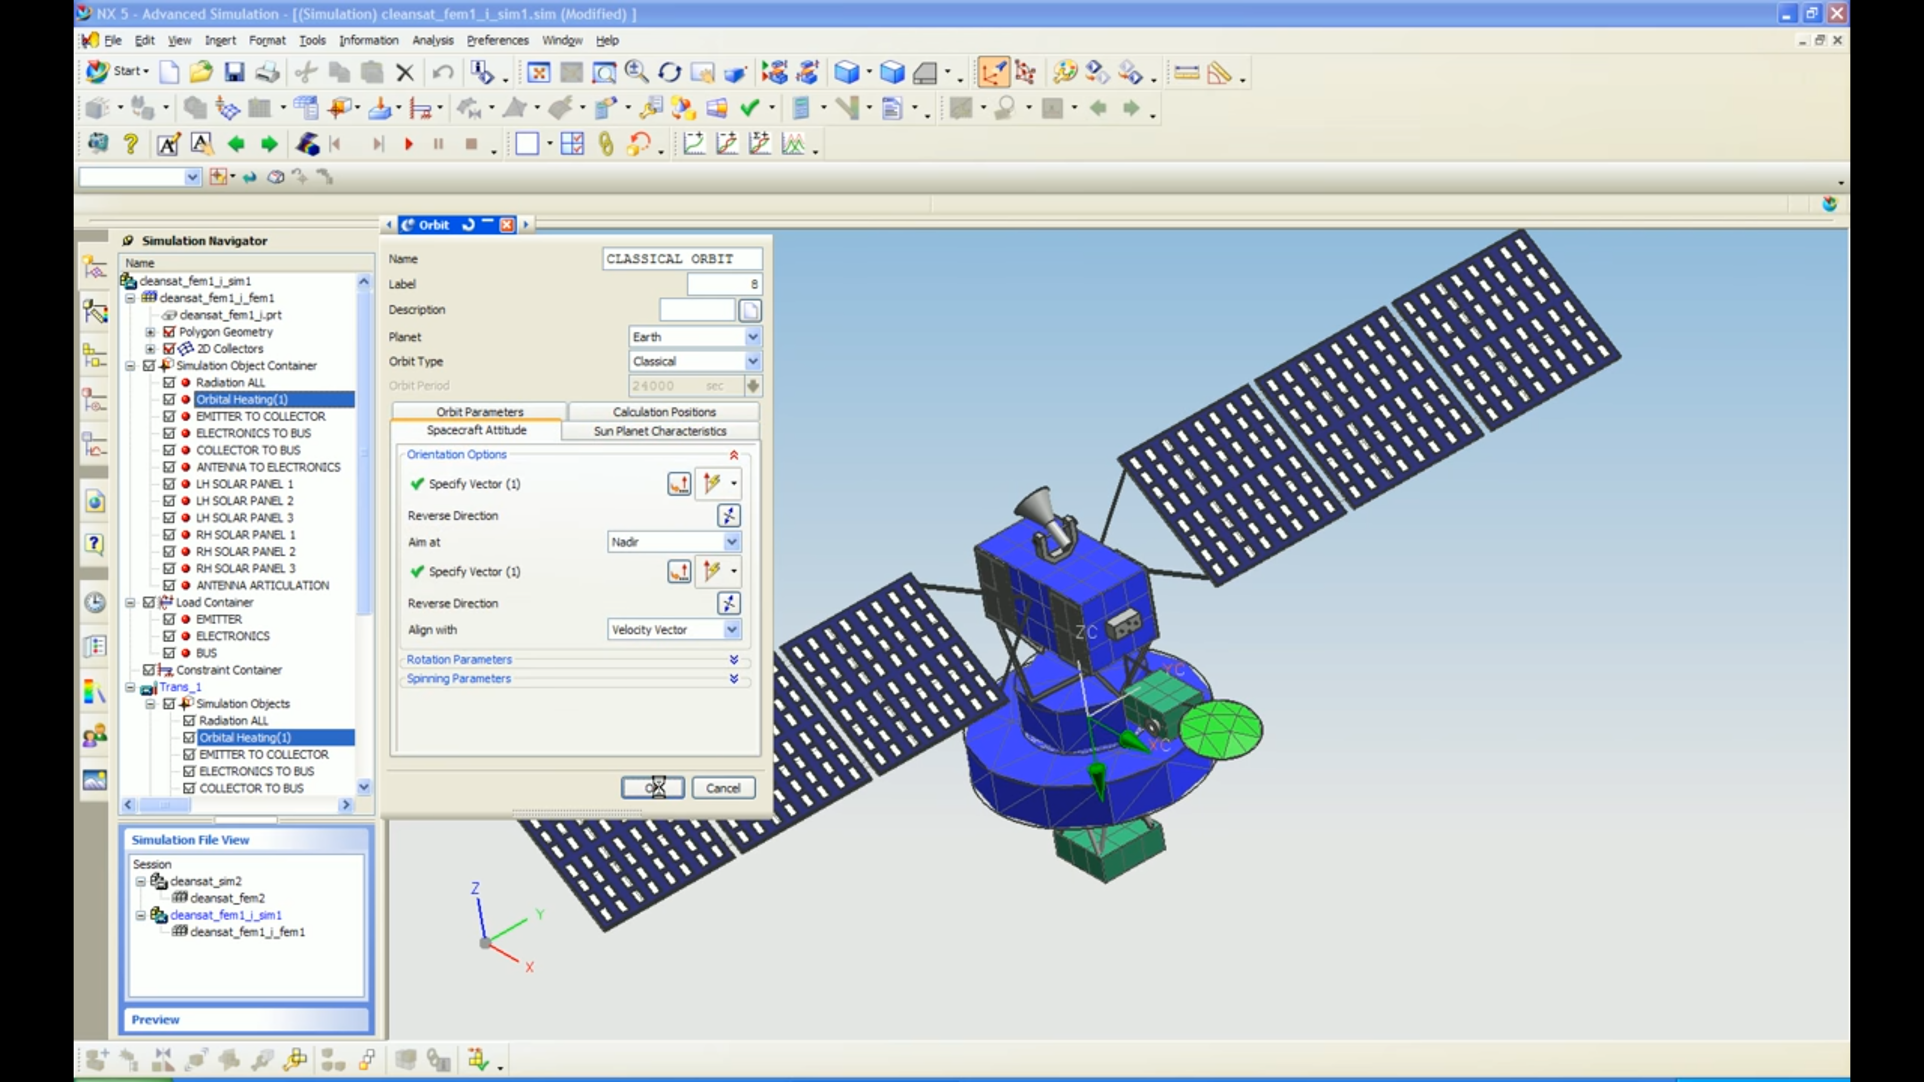

Figure 1. In-progress thermal analysis using NX (formerly known as Unigraphics)